

User Manual

Quanser Mechatronic Systems Board for NI ELVIS III



Setup and Configuration

© 2018 Quanser Inc., All Rights Reserved

Printed in Markham, Ontario.

This document and the software described in it are provided subject to a license agreement.

LabVIEW and National Instruments are trademarks of National Instruments.

All other trademarks or product names are the property of their respective owners.

**Additional Disclaimers:** The reader assumes all risk of use of this resource and of all information, theories, and programs contained or described in it. This resource may contain technical inaccuracies, typographical errors, other errors and omissions, and out-of-date information. Neither the author nor the publisher assumes any responsibility or liability for any errors or omissions of any kind, to update any information, or for any infringement of any patent or other intellectual property right.

Neither the author nor the publisher makes any warranties of any kind, including without limitation any warranty as to the sufficiency of the resource or of any information, theories, or programs contained or described in it, and any warranty that use of any information, theories, or programs contained or described in the resource will not infringe any patent or other intellectual property right. THIS RESOURCE IS PROVIDED “AS IS.” ALL WARRANTIES, EITHER EXPRESS OR IMPLIED, INCLUDING, BUT NOT LIMITED TO, ANY AND ALL IMPLIEDWARRANTIES OFMERCHANTABILITY, FITNESS FOR A PARTICULAR PURPOSE, AND NON-INFRINGEMENT OF INTELLECTUAL PROPERTY RIGHTS, ARE DISCLAIMED.

No right or license is granted by publisher or author under any patent or other intellectual property right, expressly, or by implication or estoppel.

IN NO EVENT SHALL THE PUBLISHER OR THE AUTHOR BE LIABLE FOR ANY DIRECT, INDIRECT, SPECIAL, INCIDENTAL, COVER, ECONOMIC, OR CONSEQUENTIAL DAMAGES ARISING OUT OF THIS RESOURCE OR ANY INFORMATION, THEORIES, OR PROGRAMS CONTAINED OR DESCRIBED IN IT, EVEN IF ADVISED OF THE POSSIBILITY OF SUCH DAMAGES, AND EVEN IF CAUSED OR CONTRIBUTED TO BY THE NEGLIGENCE OF THE PUBLISHER, THE AUTHOR, OR OTHERS. Applicable law may not allow the exclusion or limitation of incidental or consequential damages, so the above limitation or exclusion may not apply to you.

# Safety Information

The following symbols and definitions are interchangeably used throughout the User Manual:

|  |  |
| --- | --- |
| Symbol | Description |
| **https://lh3.googleusercontent.com/uALLqA_1-o-BxRnTR40rPmJYJD4TqUSRTidN5-eYAncLaD54onoXck7oPGl5kpmYa-NZu1XkpF3uaHX_6qxBaRyhkBJGgges0bbRZzjjjbIQ9DnysRRfKnZdH35VWtl4W-plVzea** | Caution: consult documentation for additional information |
| https://lh6.googleusercontent.com/ay0jGKpt4TB7uxlm6ZAYgsewYgKAy5UimB2xyeXymTpFciMA-RfN3WCM-nUlerduvaUGDBhqF9FSHvItKMcHF6kEDl5ZHqQxJdzofTLIA3NID6YozXqFbzCt0LljsxTR0g3bEsFY | Attention: Observe precautions for handling electrostatic sensitive devices |

# The Quanser Mechatronic Systems Board

The Quanser Mechatronic Systems board, pictured in Figure 1 is a versatile system designed to allow students to investigate and implement various sub-components of a mechatronic system from PWM generation, manipulator control and kinematics, to image processing, and state machines. The system consists of a direct-drive 5 bar linkage, manipulator-mounted camera, customizable task space image overlays, and modifiable LabVIEW controllers. The application board can be easily adapted to a wide range of mechatronics application areas such as line following and autonomous navigation.

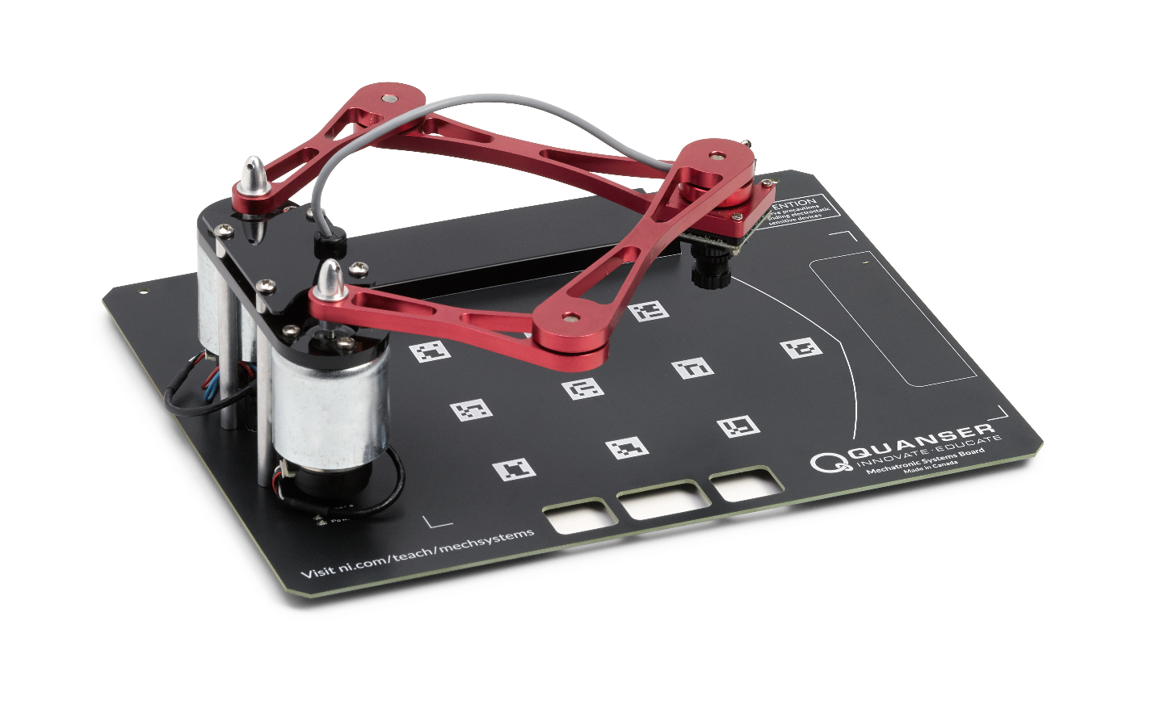

Figure 1: The Quanser Mechatronic Systems board

## Main Features

* Direct-drive brushed DC motors
* 512 count encoders mounted on each motor (giving 2048 count granularity with quadrature decoding)
* Manipulator-mounted UART camera (JPEG or RAW format)
* Replaceable task space images with magnetic anchor

|  |  |
| --- | --- |
| Caution | This equipment is designed to be used for educational and research purposes and is not intended for use by the general public. The user is responsible to ensure that the equipment will be used by technically qualified personnel only. |

## System Hardware Components

The major components of the application board are identified in Figure 3.

Table 1: Application board hardware components

|  |  |  |  |
| --- | --- | --- | --- |
| ID | Component | ID | Component |
| 1 | PCI Connector for interfacing with NI ELVIS III | 4 | Silkscreened location markers for calibration and testing |
| 2 | DC motors and encoders | 5 | Magnetic anchor for replaceable task space images |
| 3 | 5-bar manipulator linkage | 6 | uCAM-III serial camera |



**6**

**4**

**3**

**2**

**5**

**1**

Figure 3: Quanser mechatronic systems board components

### DC Motor

The board includes two direct-drive, brushed DC motors to drive a 5 bar parallel manipulator. The motor specifications are given in Table 2.

The included motors are Premotec CL40 Series Coreless DC Motors. The complete

specification sheet of the motor is available from [Allied Motion](https://www.alliedmotion.com/dc-motors/coreless-dc-motors/cl-series-coreless-dc-motors/).

|  |  |
| --- | --- |
| Caution | Exposed moving parts. |

### Encoder

The encoders used to measure the angular position of the two motors on the board are single-ended, optical shaft encoders. They output 2048 counts per revolution in quadrature mode (512 lines per revolution).

The included encoders are the US Digital E8P-512-118 single-ended optical shaft encoder. The complete specification sheet of the encoders is available from [US Digital](http://cdn.usdigital.com/assets/datasheets/E8P_datasheet.pdf?k=634748881615955589).

### Camera

The board includes a serial camera mounted downward-facing on the manipulator. The camera affords full user access to modify its functionality, and is capable of providing both RAW and JPEG format images in a variety of resolutions.

The included serial camera is a 4D Systems uCAM-III. The complete specification sheet of the camera is available from [4D Systems](https://www.4dsystems.com.au/productpages/uCAM-III/downloads/uCAM-III_datasheet_R_1_0.pdf).

**Environmental**

The QNET Mechatronic Systems is designed to function under the following environmental conditions:

* Standard rating
* Indoor use only
* Temperature 5◦C to 40◦C
* Altitude up to 2000 m
* Maximum relative humidity of 80% up to 31◦C decreasing linearly to 50% relative humidity at 40◦C
* Pollution Degree 2
* Maximum transient overvoltage 2500 V
* Marked degree of protection to IEC 60529: Ordinary Equipment (IPX0)

## System Parameters

Table 2: Application board system parameters

|  |  |  |
| --- | --- | --- |
| Symbol | Description | Value |
| Vnom | Nominal motor voltage | 18.0 V |
| τnom | Nominal motor torque | 22.0 Nmm |
| ωnom | Nominal speed | 3050 RPM |
| Inom | Nominal current | 0.540 A |
| Rm | Terminal resistance | 8.4 Ω |
| kt | Torque constant | 0.042 Nm/A |
| km | Motor back-emf constant | 0.042 V/(rad/s) |
| Jm | Rotor inertia | 4.0 x 10-6 kgm2 |
| Lm | Rotor inductance | 1.16 mH |
| ϴE | Encoder count angle (in quadrature) | 0.176 deg |

## System Setup

The procedure to set up the Mechatronic Systems board on the NI ELVIS III module is detailed in this section.

|  |  |
| --- | --- |
| Caution | If the equipment is used in a manner not specified by the manufacturer, the protection provided by the equipment may be impaired. |
| ESD Warning | The electrical components on the Quanser Mechatronic Systems board are sensitive to electrostatic discharge (ESD). Before handling the board ensure that you have been properly grounded. |



**6**

**1**

**2**

**3**

**4**

**5**

**10**

**9**

**7**

**8**

Figure 3: Components of the NI ELVIS III

|  |  |  |  |
| --- | --- | --- | --- |
| ID | Component | ID | Component |
| 1 | Antenna connector | 6 | Connection data screen |
| 2 | Ethernet connector | 7 | PCI connector |
| 3 | USB C connector | 8 | Handle latching hooks |
| 4 | Power cable | 9 | Status LEDs |
| 5 | Power switch | 10 | Application board power button |

|  |  |
| --- | --- |
| Caution | Do NOT make the following connections while power is supplied to the application board! |

Follow these instructions to setup the application board on the NI ELVIS III:

1. Power on the ELVIS III
2. Connect the ELVIS III to the network or to your computer via USB C
3. Ensure the LED on the application board power button is NOT lit
4. Position the handle of the application board over the handle latching hooks
5. Position the PCI connector on the application board so that it aligns with the PCI connector on the ELVIS III
6. Push the application board upward until the PCI connector is firmly seated
7. Press the application board power button and ensure the LED on the button is lit
8. Open the LV project *Quanser Mechatronic Systems Board.lvproj*
9. Under *Quanser ELVIS III>Build Specifications* right click **Source Distribution** and click **Deploy**

## Troubleshooting

Please review the following before contacting technical support.

1. Verify the board is properly seated on the ELVIS III and that it has power.
2. Verify that the ELVIS III is correctly set up as outlined in the NI product documentation.

### You are getting 'VI Missing' messages

Make sure the required LabVIEW add-ons listed in the Quick-Start Guide are installed.

Verify that the correct LabVIEW version is installed (The ELVIS III is only compatible with LabVIEW 2018 or later).

### Board does not respond

Check that the source distribution has been deployed as outlined above.

### Board will not calibrate

Ensure that there is nothing obscuring the calibration markers on the silkscreen.

Check the focus of the camera by opening one of the kinematics labs and waiting for calibration to fail, then manually tuning the camera lens.